

VIRTUAL TRAINING
Component-based Theming for Drupal 8 … with Pattern Lab & Twig
June 1 - 2, 2020
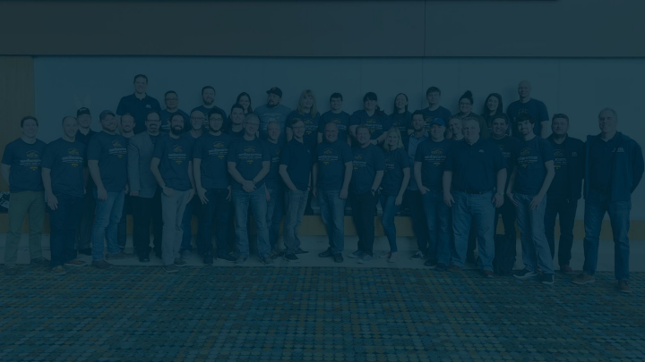About Mediacurrent
| 2
Mediacurrent
The Open Source Expansion Partner
| 3
Morning schedule Day 2

9:00 - 9:30 AM Building the Card component 9:30 - 10:00 AM Building component variants 10:00 - 10:15 AM Break

10:15 - 11:00 AM Blog content type, View Modes, & Views 11:00 AM - 12:00 PM Integrating the Cards components 12:00 PM - 1:00 PM Lunch break
Afternoon schedule Day 2

1:00 pm - 2:00 PM From our blog component 2:00 PM - 2:30 PM Integrate From our Blog 2:30 PM - 2:45 PM Break

2:45 PM - 3:15 PM Featured Content component 3:15 PM - 4:00 PM Integrate Featured Content 4:00 PM - 5:00 PM Wrap up and Q&A


Today’s
Team
Mario Hernandez
Head of Learning
Madeline Schimenti
Front-End Developer

● Live in Los Angeles
● Working with Mediacurrent since 2014 ● Over 10 years of Drupal experience
● Co-Host of Mediacurrent’s Open Waters Podcast ● Brands:
Mario Hernandez Sr. Front-end Developer
& Head of Learning
/in/MarioRHernandez
@iMarioHernandez
● WWE
● NFL
● Olympus USA ● Verifone
● VisitTheUSA.com
● Habitat for Humanity ● Harvard
● Stanford
● USC Libraries
● Emory University
● Lives in Florida
● Working with Mediacurrent since 2019
● 4 years of Drupal experience
Madeline Schimenti
Front-end Developer
/in/xxxx
@xxxxx
^{Your turn} ?
● Your Name
● Your Role
● Where are you joining us from?
● What do you hope to get out of this training?
Awesome person
Curriculum
mariohernandez.gitbook.io/advanced-components Slides can be found in the shared Google Drive
Repo for Working Drupal 8 training_theme
| 10
Atomic Design
| 11
Source: https://atomicdesign.bradfrost.com/
Atomic Design
Source: http://getbem.com/naming/
| 13
Atomic Design
Atoms Molecules Organisms Templates Pages
| 14
Atomic Design
Atoms Molecules Organisms Templates Pages
| 15
Search
SEARCH
Search this site
| 16
Atomic Design
Atoms Molecules Organisms Templates Pages
| 17
Search this site
Search SEARCH
| 18
Atomic Design
Atoms Molecules Organisms Templates Pages
| 19
LOGO HOME ABOUT CONTACT
Search this site
Search ^{SEARCH}
| 20
Atomic Design
Atoms Molecules Organisms Templates Pages
| 21
| 22
Atomic Design
Atoms Molecules Organisms Templates Pages
| 23
| 24
| 25
Introduction to components Source: http://getbem.com/naming/
A guide to
component-based theming
A deeper dive into building a Drupal website with flexible, reusable components.
You’ll learn:
❏ Advantages and challenges
❏ How to plan for success on all fronts: design, front-end, and back-end
❏ Where to find additional resources and training
| 27
Characteristics of Components
Independent
Encapsulated
Clearly Defined
Reusable
Card
1. Title or Heading
2. Eyebrow or label
3. Summary: body text
4. Author or Tags
5. Image with Custom Aspect Ratio
5
1
2
3
4
1
2
3
4
5
| 29
Breaking it down
| 30
| 31
| 32
| 33
| 34
| 35
| 36
| 37
| 38
When should we start discussing
components?
| 39
Website Process
Discovery Design _{Development} Quality
_{Assurance} Deployment Support
Digital strategy Wireframes
Technical
Architecture & Functional Specs
Quality Assurance Test Cases
Re-estimate Scope of Work
Style Tiles
Mood Boards
Responsive Design Templates
HTML Prototypes
Module
Configuration Custom Module Programming Custom Theme Development Front-End
Framework
Implementation
Execute First Test Runs
User Acceptance Testing (UAT)
Execute Final Test Run
Prepare
Production
Environment
Sync Latest Files and Data
Finalize Cache Settings
Switch DNS
Analytics/
Performance Evaluation
Feature
Enhancements Module Updates A/B Testing
| 40
Timeline
| 41
Death of the Waterfall Approach
Discovery Design Front End Development
Back End
Development
Delivery
| 42
Block Element Modifier Source: http://getbem.com/naming/
block
Name: card
HTML: <div class=”card”>...</div> CSS: .card { color: #333; }
Source: http://getbem.com/naming/
element
card__title
<div class="card">
...
<h2 class="card__title">...</h2> </div>
.card__title { color: #f90; }
Source: http://getbem.com/naming/
modifier
card--wide
card__title--large
<div class="card card--wide">
…
<h2 class=”card__title--large”>...</h2> </div>
.card--wide { max-width: 720px; } .card__title--large { font-size: 100px; }
Source: http://getbem.com/naming/
Intro to JSON
Source: https://www.w3resource.com/JSON/introduction.php
Source: https://www.w3resource.com/JSON/introduction.php
Source: https://www.w3resource.com/JSON/introduction.php
Intro to Twig
Source: https://twig.symfony.com/doc/3.x/
syntax
{{ title }}
{% if title %}
{{ title }}
{% endif %}
{# This is a comment #}
variables
{{ title }}
<h2 class=”card__title”>{{ title }}</h2> <h2 class=”card__title”>Title text here</h2>
for loops
for loops
Drupal integrations
Integration Workflow
Node edit UI: article content type
We pull our component
into the theme template,
and map Drupal’s fields
to the variables in the
component.
node--article--teaser.twig.html
src/components/article-teaser/article-teaser.twig
●●●●●● ^{| 56}
Render Arrays
Wait… what’s this, now?
When Drupal renders its fields, it wraps the field value in “helpful” markup.
●●●●●● ^{| 57}
Render Arrays
Pluck the value I want from the render array? Use Twig Field Value module?
https://www.drupal.org/project/twig_field_value
●●●●●● ^{| 58}
Render Arrays
Create a custom field template for the field with only the markup you want./templates/field/field--node--field-intro--article.html.twig
●●●●●● ^{| 59}
Render Arrays
If you experience cache invalidation issues, invoke a render of the full content variable:
{{ content|without(‘field_foo’, ‘field_bar’) }} … or ….
{% set rendered_content = content|render %}
https://www.drupal.org/project/drupal/issues/2660002#comment-12252143
https://www.previousnext.com.au/blog/ensuring-drupal-8-block-cache-tags-bubble-up-page
●●●●●●^{| 60}
Render Arrays
If you experience false positives in your component template when checking for an empty value of content fed from Drupal, try:
text: content.field_subtitle|render|trim is not empty ? content.field_subtitle
https://www.drupal.org/project/drupal/issues/2547559
●●●●●● ^{| 61}
Drupal Attributes
/src/component/article-teaser/article-teaser.twig
/core/themes/stable/templates/content/node.html.twig
●●●●●● ^{| 62}
Intro to Pattern Lab https://patternlab.io
Source: https://www.w3resource.com/JSON/introduction.php
Let’s do this!
Coffee Break
… We’ll be right back.
| 65
Stretching Break … We’ll be right back.
| 66
Lunch Break
… We’ll be right back.
| 67
Thank you!
Mediacurrent.com
Mediacurrent @Mediacurrent
@Mediacurrent
@Mediacurrent
MediacurrentDrupal
Morning schedule Day 1
9:00 - 9:30 AM Introductions & Training Environment Setup 9:30 - 10:00 AM Intro to Atomic Design, Components, & Pattern Lab 10:00 - 10:15 AM Break
10:15 - 10:30 AM Drupal attributes and best practices
10:30 AM - 11:00 AM Building components in Pattern Lab 11:00 PM - 11:15 AM Break
11:15 AM - 12:00 PM A component’s lifecycle
12:00 PM - 1:00 PM Lunch break
Afternoon schedule Day 1
1:00 PM - 2:00 PM Completing a component’s lifecycle 2:00 PM - 2:15 PM Break
2:15 PM - 3:00 PM Component variants
3:00 PM - 3:15 PM Break
3:15 PM - 4:00 PM Drupal content types, views, and view modes 4:00 PM - 4:15 PM Break
4:15 PM - 5:00 PM Wrap up day 1

